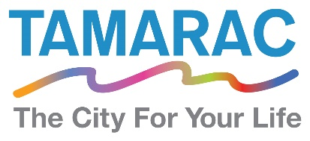

**Human Resources Technician**

The City of Tamarac is looking for a dynamic Human Resources Technician to join our Human Resources team to assist with the City’s pension plans and additional administrative and technical support functions.

The position performs a variety of administrative and technical support functions in the Department of Human Resources.  Duties include assisting in the administration of the City’s pension plan(s), employee benefit and wellness programs and leave of absence approval and monitoring processes.   Work involves recognizing, preparing and typing minutes, ordinances, resolutions, memos, contracts, legal correspondence, and other documents, as well as maintaining system documentation, researching regulations, maintaining files, calendars, and schedules.  Answers telephone, receives visitors, and ensures efficient operation of the office.

Requires an Associate Degree in Human Resources, Business, Public Administration or related area supplemented by at least three years of progressively responsible administrative support experience.  Strong computer skills required.  Experience working in a human resources environment or handling human resources functions is preferred. Preferred experience with legal documents and records maintenance in a Human Resources, insurance, legal, wellness, or leave administration environment.  Must possess a valid Florida Driver’s License. Must demonstrate proficiency in computer software applications through the completion of a skills assessment exercise.

This is an excellent opportunity to make a difference and enjoy the many benefits the City has to offer. From our supportive workforce, growing community, and comprehensive benefits package. Tamarac is the City for our Life! To learn more about the position and to apply visit [www.tamarac.org](http://www.tamarac.org).