June  2021 | Fact Check  Pensions are More Efficient than 401(k)s |  |  |  | Fact Check  #4
DB Plan up to 48% Cheaper to run than 401(k)s  A public DB pension plan allows large numbers of people to invest for the average life expectancy of a group and always has new contributors to offset mortality tables. A 10% savings.  Public pension plans are ageless. They operate in perpetuity and so they can achieve a more balanced portfolio over time. Individuals must move assets to less profitable investments as retirement nears. This accounts for a 11% cost savings.  Pension plans achieve higher investment returns as compared to individual investors, because they have lower fees and are managed by investment professionals. This generates a 27% cost savings.  About 60% of every retiree benefit check is paid for with earnings on the fund, 27% with dollars allocated by the plan sponsor (as deferred compensation to employees), and with 13% from employee contributions.  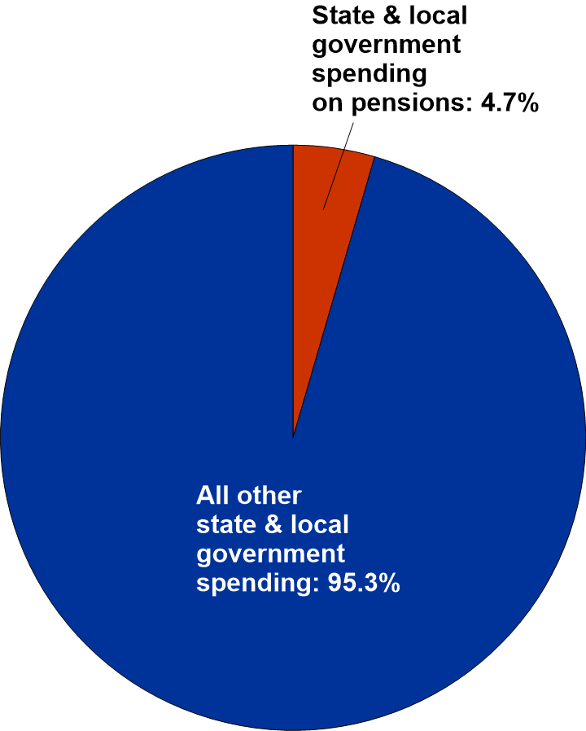  Far from crowding out other services, public  pension plans only account for 3-5% of total  budget. Source: National Association of State  Retirement Administrators, 2018. |  |  | 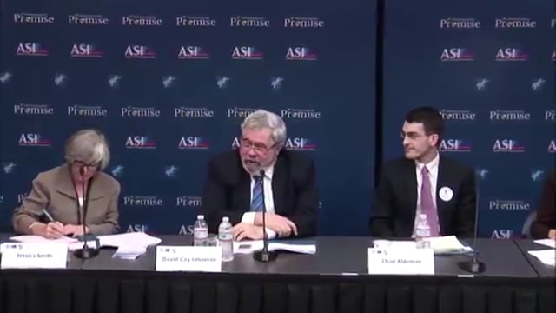
 |  |  | David Cay Johnston is an investigative journalist and author, specializing in economic and tax issues, and the winner of the 2001 Pulitzer Prize for Beat Reporting.
Pension Funding Myths
Unfunded liabilities not the same as unfunded plans

Critics often cite a public pension plan’s unfunded liability as an existential threat to future budgets, claiming it will crowd out other services, and that it creates an extra burden for taxpayers, but in reality, an unfunded liability is not the same as an underfunded plan.

Public pension plans are structured to be prefunded, and they operate in perpetuity. An unfunded liability represents the portion of money that will be needed to pay retirement benefits to every current and future employee in the plan when they retire. The unfunded liability represents only the money that will need to be earned or collected by the time they do. New employees nearly always replace retirees in public systems. If a pension plan is 80% funded, it means the plan already has enough money to pay retirement benefits to 80% of its current and future employees.

An underfunded plan, on the other hand, is one that has not met or made its annual required contribution (ARC), creating instability in the fund’s ability to earn the money required to pay those benefits. Actuaries review the pension fund annually to determine what the ARC should be for the upcoming year and to project what it might be over the next 10-20 years. This allows the plan sponsor to adjust, in real time, to market shifts. Moreover, the ARC is calculated to achieve the required earnings even when confronted with negative return years. If the plan sponsor faithfully makes the annual required contribution, there is little risk of underfunding.
 |  |  | Established in 1984, the FPPTA is a non-profit educational organization. More than half of Florida’s municipal pension plans are FPPTA members.
