

42nd Annual Conference & Expo
June 28 – July 1, 2026
Renaissance Orlando at SeaWorld
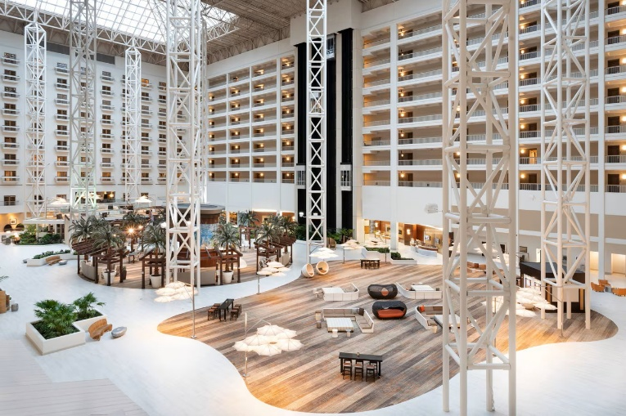
Join us for the 42nd Annual Conference & Expo for an engaging few days of connection, learning, and celebration with colleagues from across the industry.
We’ll kick things off on Sunday, June 28 with our Association’s Charitable Golf Classic at the beautiful Hawk’s Landing Golf Course in Orlando. Registration and breakfast begin at 6:46 AM, followed by a 7:30 AM shotgun start. Proceeds from this event support the Raymond T. Edmondson Scholarship Fund and the Renee Lipton Relief Fund . (You must be logged into the website to access these pages)
(Golf page link with more details)
Later that afternoon, Conference Registration will be open from 3:00–6:30 PM in the Oceans Ballroom Foyer. The evening continues with our Welcome Gathering in the Exhibit Hall from 5:00–7:00 PM this will be your first opportunity to reconnect with familiar faces and meet new colleagues in a relaxed, social setting. We encourage you to plan dinner following the event.
(Exhibit Hall page link with more details)
On Monday morning, registration opens at 7:00 AM, followed by our Opening Ceremonies at 8:00 AM in the General Session. During this time, we’ll recognize our Board of Directors, celebrate individuals who have earned their CPPT and TLC certifications, and present the Raymond T. Edmondson Service Award. We’ll also honor our scholarship recipients and hear from candidates running for Board election and re-election.
Monday and Tuesday will feature a dynamic lineup of keynote speakers and industry expert panels, offering valuable insights and practical takeaways. On Tuesday afternoon, we will hold our General Membership Meeting, where all members are encouraged to attend, participate, and share their perspectives.
We’ll conclude on Wednesday with a final General Session keynote speaker, bringing the conference to a close on an inspiring note.
(Program agenda link)
In addition to our conference programming, we’re pleased to offer the Kids Corner on Monday and Tuesday from 9:30 AM–11:30 AM. There will be fun activities such as face painting, DJ and Dancing along with a magician. Breakfast is included. If you plan to utilize this service, please be sure to register your child(ren) during the conference registration process. Additionally, a parent must accompany the child.
We also offer Guest Registration for spouses or significant others ($300), which includes access to the Welcome Gathering, daily breakfasts (Monday–Wednesday), and morning and afternoon refreshment breaks. Please be sure to register your guest by June 19, 2026.

Associates Charitable Golf Classic
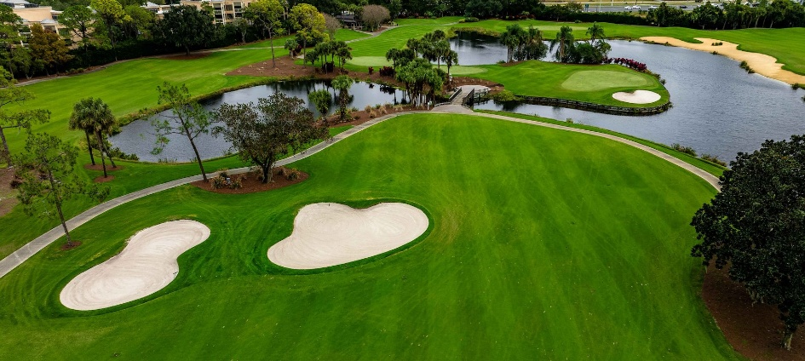
Start your conference experience on the course while supporting two meaningful causes.
Join us on Sunday, June 28 at Hawk’s Landing Golf Course for a morning of golf, networking, and giving back. Proceeds from the tournament benefit the Raymond T. Edmondson Scholarship Fund and the Renee Lipton Relief Fund.
Event Details:
- Registration & Breakfast: 6:46 AM
- Shotgun Start: 7:30 AM
- Location: Hawk’s Landing Golf Course, Orlando
Whether you’re a seasoned golfer or just looking to enjoy time with colleagues in a relaxed setting, this event is a great way to kick off the conference.
Registration and Sponsorship:
Greens Fee: $100 Trustee or Administrator
Associate $200

Sponsorship packages:
- Golf Hole Sponsor, Longest Drive (Men & Women), Closest to the Pin (Men & Women) – $800
- Golf Hole Package – $1,200 (includes four greens fees) includes:
  - Hole signage
  - Conference registration recognition
  - Four green fees
  - Recognition in The Voice Magazine
  - Awards Ceremony recognition
Breakfast Sponsor ($1,500)
- Breakfast signage
- Conference registration recognition
- Four green fees
- Recognition in The Voice Magazine
- Awards Ceremony recognition
Sponsorships include prominent signage on the course and recognition throughout the conference.

Welcome Gathering & Exhibit Hall
Kick off the conference by connecting with peers and exploring the latest products and services in the industry.
Join us on Sunday evening from 5:00–7:00 PM in the Oceans Ballroom for our Welcome Gathering. This casual networking event is the perfect opportunity to reconnect with colleagues, meet new attendees, and engage with our valued exhibitors.
What to Expect:
- Networking in a relaxed, social setting
- Access to exhibitors and industry partners
- Light refreshments
We encourage you to take advantage of this time to build connections before the conference programming begins.

Exhibit Hall
The Exhibit Hall is a central part of the Annual Conference & Expo—designed to bring together attendees and industry partners in a dynamic, interactive environment.
With approximately 70 booths, you’ll have the opportunity to connect with a wide range of organizations, including:
- Associate members
- Actuarial firms
- Investment managers
- Law firms
- Custodians
- And other industry service providers
This is your opportunity to explore new services, ask questions, and build relationships with firms that support your work.

Networking & Refreshments
The Exhibit Hall isn’t just a place to visit—it’s where the conference community comes together.
All of the following take place in the Exhibit Hall:
- The Welcome Gathering (Sunday evening)
- Daily breakfasts
- Morning and afternoon refreshment breaks
These built-in opportunities make it easy to connect with colleagues and vendors in a relaxed, social setting.

Exhibit Hall Raffle
To encourage engagement and interaction, we host a daily raffle in the Exhibit Hall.
Each Trustee will receive a raffle card in their registration packet for the corresponding day.
How it works:
- Visit participating vendor booths
- Have each vendor check off your raffle card
- Submit your completed card at the FPPTA Booth
Once submitted, you’ll be entered for a chance to win prizes provided by FPPTA and participating vendors.
Important: You must be present to win.

Raffle Schedule
- Sunday (Welcome Gathering): Drawing at 6:00 PM
- Monday & Tuesday: Drawings held during the final afternoon refreshment break

Make the Most of Your Time
We encourage all attendees to take full advantage of the Exhibit Hall:
- Connect with new associate and vendor firms
- Strengthen relationships with long-standing partners
- Ask questions and learn about available resources
- Participate in the raffle and daily activities
The Exhibit Hall is an important part of the conference experience—offering both valuable information and meaningful connections.

Kids’ Corner
We understand the importance of balancing professional development with family needs. That’s why we’re pleased to offer Kids Corner during the conference. There will be fun activities such as face painting, DJ and dancing along with a magician. Breakfast is included.
Available:
- Monday & Tuesday
- 9:30 AM – 11:30 AM
Kids’ Corner provides a safe and engaging environment for children while you attend conference sessions.
Important:
Please be sure to register your child(ren) during the conference registration process, as space may be limited. One parent must accompany the child.

Guest Registration
Bring a guest and share part of the conference experience together.
For $300, guest registration includes:
- Welcome Gathering (Sunday evening)
- Breakfast (Monday, Tuesday & Wednesday)
- Daily morning and afternoon refreshment breaks
Guests are welcome to enjoy the social aspects of the conference while you participate in sessions.
Registration Deadline: June 19, 2026

